24/03/2021 – 5:30pm
Hosted on Zoom.

Sunderland AFC: Kyril Louis-Dreyfus (KLD), Kristjaan Speakman (KS), Steve Davison (SD), Tom Sloanes (TS), Oscar Chamberlain (OC), Chris Waters (CW).

Groups Branch Liaison Council, Red & White Army, Senior Supporters Association, Sunderland Supporters Liaison Group

Present: Jim Gilling JG (BLC), Cath Reid CR (BLC), Phil Pollard PP (BLC), Joanne Youngson JY (BLC), Andrew Hird AH (RAWA), David Rose DR (RAWA), Ian Crow IC (RAWA), Martyn McFadden MM (RAWA), Malcolm Bramley MB (Senior Supporters), Paul Andrew PA (SLG), Mike Hillam MH (SLG), Peter Shippey PS (SLG), Richard Porthouse RP (SLG)

- Welcome from Sunderland AFC

CW informed the group that the club is committed to further engagement. This includes four meetings every season with the Supporter Collective going forward.

CW set out the agenda and format for the meeting.

- Supporters’ Groups Introduction

Each supporters’ group made introductions and extended a warm welcome to Kyril Louis-Dreyfus, Kristjaan Speakman and Steve Davison who were attending the meeting for the first time.

- Chairman’s message

“It’s nice to meet you all online and hopefully we will get to meet face to face in the near future.

Before we go into the strategy and plan, I wanted to share my intention from an ownership perspective with you.
Every owner has different intentions and reasons of buying a football club and to understand mine I wanted to share a couple of things about my background with you.

Firstly, I am a very passionate football fan, having grown up around this sport with my father.

Also, I grew up around the family business. The business is essentially growing and distributing food around the world and is celebrating its 170th anniversary this year.

With having such a long history within a company that has stayed in the family for so long, it had to weather a lot of wars and crisis over the last two centuries. We always gave the next generation two distinct values that I would like to share with you.

Firstly, to understand and respect the responsibility that we have to help feed the planet and secondly was to always think long term and try and improve the business in a way that ensures when the next generation takes over, they inherit a business that is better than the previous generation had.

I will have the same two values at heart throughout my ownership of this football club. I understand and respect the responsibility that I have. In the case of this club, it is to all the fans and to the community that cares so dearly about the club and secondly, I will always think long term to try and improve the club so that whoever comes after me can continue to develop the club even further.

I think regardless of how long I will stay at this club, maybe 10, 15 or 20 years, I will only represent a small part of this club’s rich history. However, I hope that this ownership and our era will be the start of a long lasting and sustainable and hopefully more successful era for this football club.

I would now like to address the changing in ownership and the changes in the board. While I am the largest shareholder at the club, Stewart, Juan and Charlie will each retain a minority shareholding in the club and will support it as much as they can. I want to assure you, I have the executive control of the club and the majority on the board.

Since the takeover was announced we have appointed two new directors. Igor Levin, who is our family’s attorney and used to be a former director at Marseille and Patrick Treuer, who I am sure you will meet, he is our CFO of our family business. Both of them will be joining our already existing directors Tom Sloanes and David Jones.

Moving forward we want the board to be more active and a valuable support tool for the executive management. We will have regular board meetings going forward.

Finally, I think it is important for me to say, we want to continue these structure dialogue meetings. We want to have these four times a year and I want this to be open and transparent between us. You can expect me to always be truthful no matter if you like the answers or not I will always be very transparent with you. All of you have been very close to the club, so you are all aware what a difficult situation the club finds itself in with the pandemic and other reasons. It will require a lot of teamwork and effort from all of us together to weather out this pandemic. I am looking forward to working alongside you and I will now like to pass over to Steve to elaborate on some of the strategies we want to implement”.

- Sunderland AFC Presentation

The five strategic themes the club will focus on going forward are:
- Establish a high-performance culture across the club.
- Developing a football philosophy based upon Sunderland’s values and identity.
- Opportunity for young players through a holistic development programme
- Evidence-based decision making embracing data and technology.
- Aligned and engaged with communities, supporters and businesses.

Organisational Structure

- There was a summary and overall look at the new structure plan for Sunderland AFC.
- The club wants greater alignment between the business and football side and the new structure focuses on this.
- Having a clear structure is very important as its aids our communication within the club.
- It helps us makes sure we can create a high-performance culture and improves decision making.
- The club could not provide any staff names as they are still in the process of making appointments in and around the positions identified on the chart.

Over the next few weeks and months supporters will see key people being appointed into these roles, some already existing in the club, but one or two new names will be joining. The whole organisation will be populated by the end of the season. There will be a clear structure, so all staff know what their role is.

Business Update

- The club wanted to improve the live stream options to improve the experience for home games. Since the improvements there has been more supporters watching
- There is an aim to fill remaining senior roles within the operating structure by the end of the current football season.
- Stadium WIFI was being developed and tested in order to ensure provision throughout the stadium bowl.
- Investment planning was underway including the consideration of various technology upgrades that could move the club forwards more effectively.
- The first board meeting will be taking place in April.
- A large number of staff had returned from furlough, including the return of ticket office staff.
- The club shop had performed well in terms of online sales and it was expected that the shop will remain closed until nearer the start of the 2021/22 season.
- The ticket office will also remain closed at this time.
- Discussions were ongoing with promoters to support the return of concerts at the stadium from 2022.
- Operational planning was underway to ensure the return of supporters for the 2021/22 season in the safest possible way that complies with guidance.

Football Progress

Kristjaan has appreciated the warm welcome he has received from the supporters since arriving at Sunderland AFC. He has been at the club for 100 days and has thoroughly enjoyed his time so far. Kristjaan Speakman confirmed that there had been positive changes since his arrival in November. These changes were starting to make an impact and were starting to show in recent results.

- KS fully understands the role a successful club has in the community, so hopefully that is something that can be delivered.
- There is a lot of strategy and thinking about what the club will do in the future.
- There is also an appreciation that action is required now, hopefully that will have been recognised with what has been happening on and off the pitch at the Academy recently.

- A High-performance culture and holistic strategy- This was being embraced throughout the whole structure of the club.
- Football identity - Needs to be representative of the people in the community and all SAFC fans. Focused on an increased attacking output and a quicker and more intense press out of possession since December.
- Organisational structure
  - Academy Leadership Structure - A new Academy Leadership Group has been established – Lewis Dickman, Leann Cowperthwaite & Stuart English
  - By having a diverse leadership group, with a range of skills, this will prove valuable in supporting all staff and the players in delivering a high-performance product.
  - Heads of Domain – Currently looking at the expertise across the Academy from U8 level to 1st team to ensure the club has the depth in staff quality to deliver a higher standard for all age groups.
  - We no longer separate the 1st Team and Academy set up, it is all one group with the same structure and format across all areas.
  - Head of Player Recruitment has been appointed, starting on Monday 15th April.
  - Head of Analysis and Data has been appointed, starting on Monday 29th March.
  - Looking at two additional areas around performance and medicine to see how that fits in the overall structure.
  - New Scalable Strategy - Rather than look short term, we are looking at what we need now and what we will require as the club as we move to higher divisions.

Further key points included:
- A football philosophy is to be developed across all age groups, including the first team and Sunderland Ladies. There will be a Sunderland way of teaching the game to all ages.
- Sunderland Ladies – Unfortunately there has been two back-to-back seasons that have been void.
- Kristjaan has been in discussions with manager Mel Copeland to start to identify the strategy for the Sunderland AFC Ladies team to grow over the next 3 – 5 years.
- A strategy is being developed to support the women’s programme and provide all the provision to match the 1st team.
- The club would like to see the quickest progression to Championship status (tier 2) as soon as possible.
- The provision and use of data and analytics will also be available to the Sunderland Ladies structure so there is a consistency of approach throughout the club.
- Player retention and release programme is now being applied through the u16/18 and u23 age groups. It will conclude at the end of the season with the 1st team squad.
- Plans are in place to look at the squad composition and the next transfer window.
- There are two plans depending on what division Sunderland AFC will be in for the 2021/22 season.
- There will be a sustainable model introduced as part of the new Academy strategy.
- Facility Renovation - A lot of work had been put into the review of the academy to ensure the appropriate infrastructure and support mechanisms in order to drive high performance, outline clear development pathways and prevent the loss of promising young players.
- KS has been aware that the loss of young players has not gone down well with supporters previously.
- KS mentioned his previous background in terms of player development.
- KS will be heavily involved in player development and player pathways now, so the loss of younger talent is something that the club is looking to put a halt on immediately.

Season Cards

All supporters will need to take action to renew as there will be no rollover / automatic renewal from previous years.
- The club has decided to treat all season card holders from 2019/20 with reserved seats and 2020/21 season the same as the fairest approach.
- There is no roll over, all seats are reserved, and fans need to take action to renew their season cards. The club felt it was wrong to auto renew and assume everyone wants their season card given the exceptional circumstances created by the pandemic.
- Season cards will be available for current season card holders to renew, 2019/20 season card holders to renew.
- Supporters that did not have season cards in the last couple of seasons that want to buy a new season card can also purchase during this early bird stage.
- An approximate 10% increase from previous years prices.
- £1 charity donation from every season card sold will go to the #SunderlandTogether campaign to add to the £174,000 already raised.
- Early bird period from 29 March to 13 April.
- If during 2021/22 season supporters cannot attend due to Covid related events, proportional match refunds will be issued on a monthly basis.
- Supporters’ groups asked to support and encourage on-line renewals.
- There will be FAQ’s available for all supporters to help with renewals.
- The ‘physical’ ticket office will not open during this time, although ticket staff are responding to emails and calls.
- Supporters will receive an email explaining the renewal process.
- For fans that have not provided an email, they will be sent a renewal pack in the post.
- The following slides were provided showing the price difference, comparisons to the rest of the league and season card price history at the Stadium of Light.

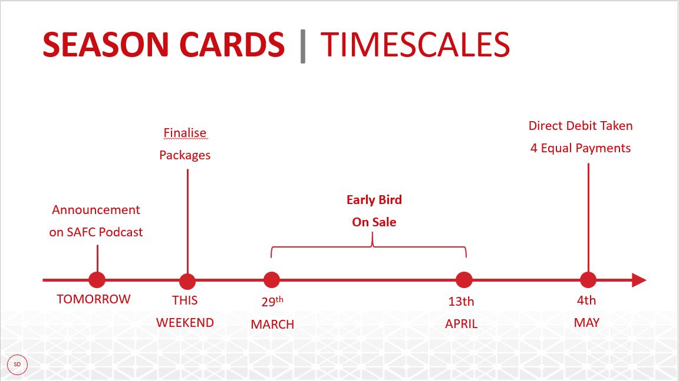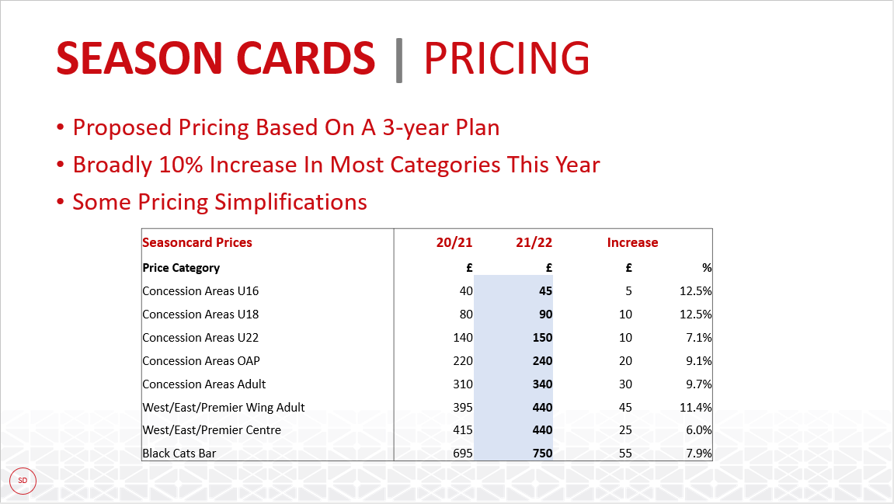
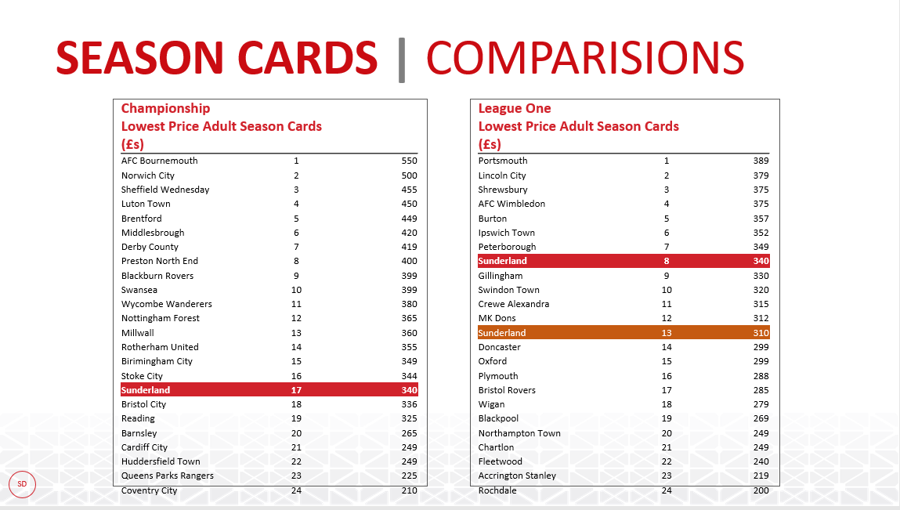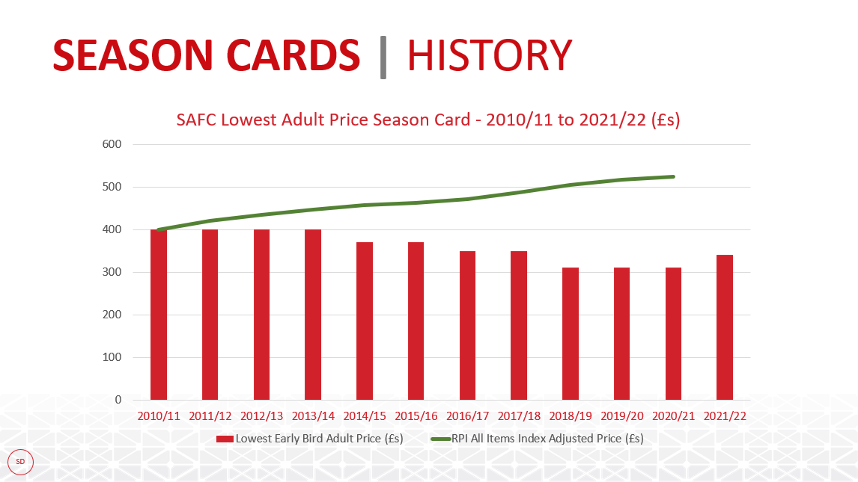

Matchday Experience
- There will be a three-year improvement plan to enhance the whole day.
- Looking at the dwell time around the stadium, so there will be a review of all activities pre-match and post-match to encourage fans to arrive earlier and depart later around the game.
- This will be a long-term plan and supporters’ feedback will be key to implement these improvements.
- Fans Survey will be taking place soon to gather feedback from the entire fanbase.
- The improvement plan needs to be inclusive and cover fans from all age groups, as many supporters want different things.

Community Engagement
- There is a strong commitment to work together and enhance the relationship with the Foundation of Light.
- Virtual Wembley Tickets - Everyone’s efforts from the fan groups, Foundation of Light and Sunderland AFC was praised as over £174,000 was raised by fans for the four local charities.
- Discussions have also been held with Sunderland City Council and Sunderland University.
- It was proposed that a sub-group to work with the Foundation of Light will be established.
- Action was proposed to set up a sub-group with Sunderland AFC, Foundation of Light and fan groups working on more #SunderlandTogether campaigns in the future.

- Questions & Answers

Branch Liaison Council Questions:

JG (BLC) Q: Will supporters that did not stream this season be able to roll over their season card?
A: SD (SAFC) – Yes, these supporters will have their 20/21 payments credited to their ticket account to use. This can be used to contribute to next year’s renewal. A further point if supporters do not wish to roll payment over or do not wish to renew a season card next year, they can claim a refund. Those renewing season cards will be processed first, then those who request a refund will be processed at the end of renewal period.

JG (BLC) Q: There are supporters that want to pay for season cards by cash as they do not use a credit or debit card, is this possible?
A: SD (SAFC) - The ticket office will not be open for this early bird period. We will review if cash payment is available. Further information will be available following the meeting.

JG (BLC) Q: Are Black Cat Points going to be frozen?
A: SD (SAFC) – Yes, they will be frozen

JG (BLC) Q: Are there any plans to improve the food and beverage offers for supporters in the stadium?
A: SD (SAFC) - Concourse catering kiosks management has now been brought in-house. This provides more flexibility. The club have embarked upon negotiations for a new drink’s contractor, which terminated during course of last season, hoping to have some very positive news going forward.

JG (BLC) Q: What are the plans for the fan zone?
A: SD (SAFC) – We will review this area in the light of the results of the Fans Survey.

JG (BLC) Q: It is great to see that Sunderland Ladies are going to be kept intact and investment will be made. You mention the same philosophy is going to be made across the Sunderland Women’s and Men’s team, will that include bringing female players through the academy?
A: KS (SAFC) - Yes 100%. There is a different route for Sunderland Ladies, they have a RTC programme U16, then Academy programme which is often located on a different venue, most linked to an Education establishment a lot of colleges will run and then back to the club with the senior set up.

JG (BLC) Q: A release date of home and away strips is normally kept too close to August. Would the club consider launching the strips earlier in the close season? In a previous season, supporters were given the opportunity to vote for their favourite strip, contract permitting, would the club consider this will help to improve revenue as people will purchase a strip they have voted for? Finally, on retro shirts, the club shop currently sells shirts in club shop from another company who sell retro shirts, if you look at several other clubs, they have contract with say Adidas but sell original Hummel retro shirts, could the club look to contact original strip manufacturer and sell original retro rather than a copy of the shirt?
A: SD (SAFC) – The process for the new shirts has already began, so we cannot get fan involvement in the design at this stage, but we will consider this for future years. We will have a look at releasing the shirts earlier, this will have to be discussed with Nike. Our specific contract with Nike means we cannot release Hummel retro shirts.

Red and White Army Questions:

AH (RAWA) Q: - What plans do the club have with regards to selling season tickets if the government continues restrictions on the numbers to circa 5-10k. Will this information be relayed to supporters when selling season tickets?
A: SD (SAFC) – Football is dealing with a great deal of uncertainty at the moment. We are unsure on what the government are going to say in subsequent phases of the roadmap or what the EFL will lobby for. I do not envisage that we will be able to fill the stadium at the start of next season. We will do everything we can to make this process as smooth as possible for everyone. Many clubs followed Sunderland AFC’s previous matchday bubble plan, so we have a great team ready to deliver this. As soon as a plan is in place, we will share this with supporters. In terms of how we are dealing with more season cards than seats, that is something I think we have to go away and work on, how to become allocated is not something we have thought of.

AH (RAWA) Q: What plans are in place to engage with Junior Supporters?
A: SD (SAFC) - I think we have to do more than ever before to re-engage with those groups; we have got to think of it from their perspective. I would like the club to re-engage with younger supporters via our fan survey to find out what they really want. We have got to look at all groups, younger, female, senior, disabled supporters, there will be some alignment, we are trying to create a matchday for everyone, so having an area for young supporters is something we will possibly try to embrace if we can.
KLD (SAFC) - Part of the reason we want to link with the Foundation is because they go into dozens of schools a month and we think this is one area the club can engage with the Foundation of Light. We know the youth these days have a lot of different options of entertainment these days. So, for us as a club, it was clear if we want them to go to the stadium and watch games then a style of play was not an option but a necessity.

DR (RAWA) - Q: On the presentation point of offering help for season cards, we just want to thank you for taking such an ethical approach to season renewals and think it is to be applauded. We all want fans back in the ground for the new season. I guess with that comes a slightly different campaign to what footballs ever been used to before and it needs to cover all the emotive reasons why we all love going to matches on a Saturday, Tuesday and away matches. If we can help during that process or through the summer, in terms of amplifying the campaign, we are here to do that.
SD (SAFC) - Thanks for the offer of help and yes, we will take you up on that. I think we all appreciate we happen to work at the football club, but everyone in the community cares about the club, its unique in Sunderland. We are always going to be appreciative of the support of supporter groups to try and make things work effectively. As far as the season card campaign is concerned, we will be starting with a particular campaign around the season cards and probably, the campaign will morph into different things throughout the summer. For one thing everyone has been impacted in different ways and different messages will suit different people, clearly building on the fact we’re trying to build closer relationships, working with the fan’s groups, we actively want to do that and certainly something we are going try to build.

As far as not auto renewing, it as a difficult decision, I felt it was wrong to auto renew when some people had not operated their direct debits for over a year, that felt completely wrong to us, the timescale wasn’t right to us at all, but we wanted previous season card holders to retain their seats. as far as help with campaign. We need help wherever possible to try to encourage people to renew electronically and I am well aware of the challenges, but if people could go down that route, I do think that would make a massive difference for us.

MM (RAWA) Q. – If Sunderland must go down the playoff route, is there any information the club can share with us on plans for supporters attending the EFL League One Playoff Final?
A: SD (SAFC) - We have not been informed formally about whether supporters can attend the playoff final. Rest assured if there is news the EFL will release it publicly. If we are taking part in this game and receive any information, we will inform all supporters.

Senior Supporters’ Association Questions:

MB (Seniors) Q: Matchday ticket prices, whether we are in league one or championship will there be a roughly 10% increase on price on that as well?
A: SD (SAFC) – Matchday ticket prices are being looked into at this time, but broadly there will be a 10% increase.

MB (Seniors) Q: Are there any plans to re-open the Premier Concourse?
A: SD (SAFC) - We need to generate enough match day sales and walk ups to justify re-opening the premier concourse. That is a decision we will have to take when we see how many season cards have been sold.
If we do have to operate in a restricted capacity, then we will be opening the premier concourse as part of getting as many fans as possible in the stadium. In terms of communication, if we open because of season card sales, then we will communicate with those who moved to see if they would like to return to their original seats.

MB (Seniors) Q: You mention fans returning, will Steve Neill’s working group continue?
A: SD (SAFC) Yes. As soon as we get the rules on fans returning, we will need to have detailed plans and we will need to have supporter involvement in those discussion.

MB (Seniors) Q: Will you be able to consult or let the fans groups have a draft of the survey?
A: SD (SAFC) - I fully expect to have an active discussion with all the supporter groups about the content of the survey. We want to represent interest of all the groups, we will have specific questions we want to ask as a club, but there will be questions supporter groups want to include, we will work together.

MB (Seniors) Q: Bearing in mind the abuse report that came out this week, are you satisfied with our safeguarding procedures or do they need any formal review?
A: KS (SAFC) - I do not think we’re ever going to be satisfied, I think it is natural that it is continually moving, and we need to stay ahead of the curve on what’s expected from the club and obviously the new information available from those enquiries. We had a meeting yesterday around mapping out our safeguarding training for the next 12 months. The club has been well placed in having the policies and procedures, as we have a yearly safety audit for category 1. From our point at the minute, it is a work in progress, we need to be right at the forefront whether it be education or statutory.

SAFC Supporters’ Liaison Group Questions:

PA (SLG) Q: Are there plans in place to connect with County Durham, South Tyneside, Gateshead, and Northumberland and as supporters can we support the club in reaching out to that wider fan base?
A: SD (SAFC) - We are well aware supporters come from the whole region, we did quite a lot of work on postcodes, and have a lot of data on geographic age etc. We absolutely want to engage with the region, I am not limiting it to Sunderland as a city, it is quite clear we need to go beyond Sunderland. We would love to have done more engagement, our engagement so far has been on calls like this with people over zoom or teams etc, we are all dying to meet with people in person where it is easier to build relationships.
KS (SAFC) - Lewis Dickman from the academy is running a working group with grass roots clubs, so I think we have a duty of care to support the grass root programme going on around the whole region.

PA (SLG) Q: You have a clear strategy and vision as to how you would like things to move forward. From our point of view, there is also the supporter experience on a week-to-week basis which could provide opportunities for more regular dialogue. I am thinking, for example, areas such as media coverage, streaming the under-23s, the club shop, and merchandise. Do you see a potential use of focus groups for supporter experience, that could look at ad hoc areas, such as media output, the fan zone, etc.?

A: SD (SAFC) - It is absolutely clear we want to engage with fans groups and the wider community, we are still in process of how we will establish how we’re going to do that, which is why I wanted to put this subgroup on engagement because I felt it was something we could actively work together on and achieve far more together. I feel doing this in a very structured way is absolutely right. Going onto the second point there is no doubt there will be specific topic points where we will want to get opinions and views and we will do what we can to bring in people like yourselves to get involved in those discussions.

JG (BLC) Q: Please can I add one more thing, we have got ongoing discussions at this time to help our supporters through the BLC digital inclusion group. We helped over 1,000 supporters to get online and register their matchday bubble at the Foundation of Light with great support from the ticket office.
The BLC is here to offer that same facility to the club if you want help to assist those supporters who do not have access to use a computer to register their season cards?
A: SD (SAFC): Thank you Jim, that is certainly something we’ll need to take a look at. We are grateful for the offer from the BLC and it is something I’m sure we’ll take you up on. We will get back to you on this.

- Actions

Action 1 - Supporters’ groups to endorse the season card campaign and share key messages across social media to help supporters.
Action 2 - Establish a new working group with Sunderland AFC, Foundation of Light and fan groups to work on community engagement.
Action 3 - SD to explore season card cash payment options.
Action 4 - SD to finalise the kit release date recognising the desire for it to be earlier than previously.
Action 5 - A new Fans Survey will launch soon; all fan groups will work with Sunderland AFC to set up and launch.

- Date of Next Meeting

The next meeting will be held on Tuesday 11th May.

Meeting closed at 8.00 p.m.

